AIR FORCE SCHOOL ,BAMRAULI
MONTHLY SPLIT-UP OF SYLLABUS
Class: III Subject: English

Month | Name of the Book | Topic / Sub Topic
April  &  May | New learning to communicate | MCB- L-1 A Fireman’s Day  L-2 There is Ice Cream in my Eyes  WB – L- 1 & 2  Grammar :L-1 Remembering What you have learnt  L-2 Nouns :- Proper common and collective
June  &  July |  | Grammar L-3 Nouns :- Number  MCB :L3 Did I make a promise  L-4 A Dog loves Cakes  WB : L-3 & 4  Grammar : Unit 4- Do you know their names -1  Unit – Do you know their name -2  Unit 13 : Nouns- Gender  Unit -6 Articles – A, An ,The  LR:- L-1 When mummy was little Girl  Writing : Paragraph Writing
July | Periodic Test :- 01
August |  | MCB L-5 Fire in Hotel  L-6 The magic Ring  Poem Gorilla  WB: L-5 & 6  Grammar : Unit 5 Adjectives  Unit 17: Adverbs
September |  | Grammar : Unit :8 Conjunctions  Unit :9 Prepositions  Unit 20 Subject and predicate
September | Half Yearly Exam
October |  | MCB: L-7 A Shooting Test  L-8 The Bell of Atri  WB:  Grammar Unit 12: Verbs , Tenses  Unit 16 : Verbs ,Continuous Tenses  Unit 21 Verbs : Base Form  LR: L6 Two Friends
November |  | MCB L-9 The toy Violin -1  Grammar L-15 Pronouns  L-14 Words which sound the same  L-18 Opposite  Writing – Picture composition
December |  | MCB: L-10 The toy violin -2  Grammar L19 Words which mean the same  LR L-9 The camel who Humped
January |  | MCB L-11 Hijacked  Poem – I Saw  Poem – The town child  Poem – The country child
January | Periodic Test :- 02
February |  | Revision for Term end exam
March | Annual Examination

.

AIR FORCE SCHOOL, BAMRAULI
MONTHLY SPLIT-UP OF SYLLABUS
Class: III Subject: Hindi

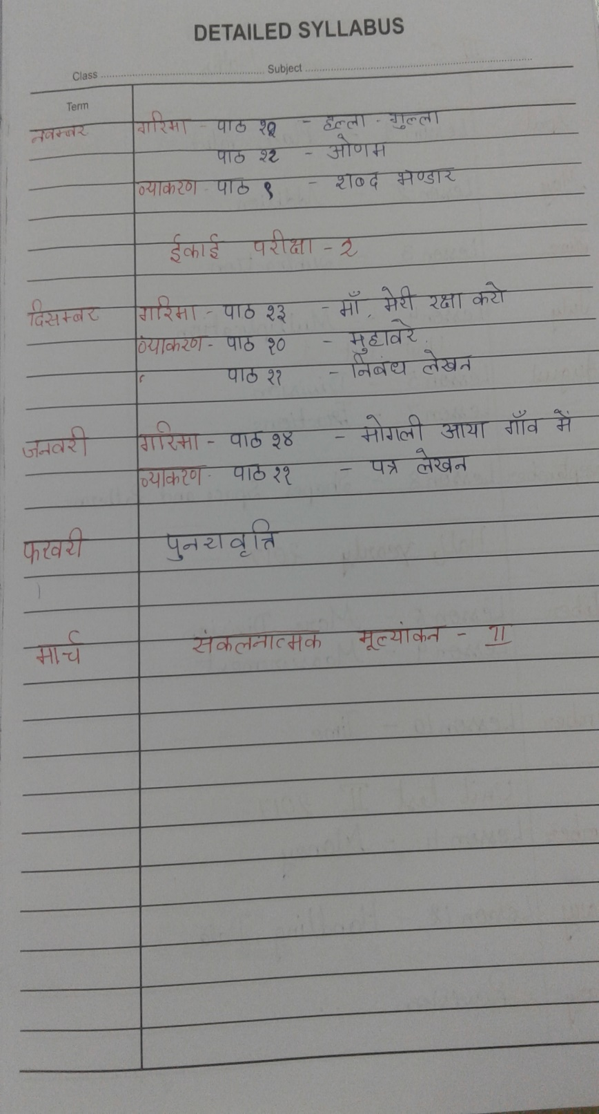
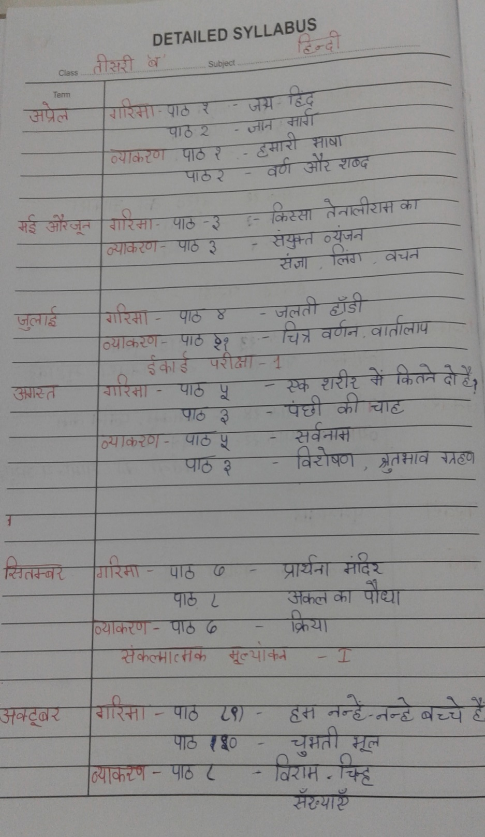

AIR FORCE SCHOOL ,BAMRAULI
MONTHLY SPLIT-UP OF SYLLABUS

Class: III Subject: Math
Month | Name of the Book | Topic / Subtopic
April  &  May | Number Line  Number Line | Le- 01 Place Value  Le- 02 Addition
June  &  July | Number Line | Le-03 Subtraction  Le-04 Multiplication
July
August | Number Line | Le-05 Division
September | Number Line | Le-07 Fractions  Le-08 Shapes ,Space and patterns
October | Number Line | Le-06 More Division  Le -09 Measurement
November | Number Line | Le -10 Time
December | Number Line | Le – 11 Money
January | Number Line | Le-12 Handling Data
February | Number Line | Revision
March

AIR FORCE SCHOOL ,BAMRAULI
MONTHLY SPLIT-UP SYLLABUS
Class: III Subject: EVS

Month | Name of the Book | Topic / Sub Topic
April  &  May | Earth Works  Earth Works | Le-01 In the family  Le-02 Our sense organs  Le-03 Work people do
June  &  July | Earth Works | Le -04 Games are fun  Le-05 Plants around us  Le-06 Leaves in our lives
August | Earth Works | Le-07 The world of animals  Le-08 Worms and insects  Le-09 Birds
September |  | Food for every one
October | Earth Works | Le-11 Cooking Food Our Clothes  Le -12 Water for all  Le-13 Storing Water
November | Earth Works | Le-14 Houses  Le-15 Animals in our homes  Le-16 Mapping the neighborhood
December | Earth Works | Le-17 Travel Time  Le-18 Communication
January | Earth Works | Le-19 Pottery
February | Earth Works | Le – 20 Clothes we wear  Revision
March

AIR FORCE SCHOOL ,BAMRAULI
MONTHLY SPLIT-UP OF SYLLABUS
Class: III Subject: Computer
Month | Name of the Book | Topic / Sub Topic
April  &  May | Boot-Click –Enter  Class -III  Boot-Click –Enter  Class -III | Le- 01 Topic :- Hardware and Software  Le-02 Topic :- introduction to Windows 7
June  &  July | Boot-Click –Enter  Class -III | Le-03 Topic :- MS Windows 7 –Accessories and Gadgets
August | Boot-Click –Enter  Class -III | Le -04 Topic:- More about MS Paint
September | Boot-Click –Enter  Class -III | Revision for SA I Le- 1,2,3,4
October | Boot-Click –Enter  Class -III | Le-05 Topic ;- Introduction to MS Word 2010
November | Boot-Click –Enter  Class -III | Le –06 Topic:- LOGO – An Introduction
December | Boot-Click –Enter  Class -III | Le- 07 Learn to be careful
January | Boot-Click –Enter  Class -III | Le – 08 Introduction to tux Paint –An Open source software Cont…..
February | Boot-Click –Enter  Class -III | Le – 08 Introduction to tux Paint –An Open source software
March | Boot-Click –Enter  Class -III | Revision for
March

