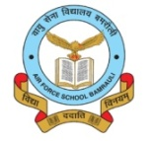 AIR FORCE SCHOOL, BAMRAULI
MONTHLY SPLIT-UP OF SYLLABUS
Class: V Subject: English
Month | Name of the Book | Topic / Sub Topic
April  &  May | New Learning to Communicate  Workbook  Grammar Tree | MCB L-1 Life’s Lighter Moments  L-2 Too Many Books  Workbook L 1, 2  Grammar L-1 Remembering what you have learnt  L-2 Adjectives  L- 3 Adverbs and its types  Literary Reader – L- 1 The great Adventure
June  &  July | Lit. Reader  Workbook  Grammar Tree  Grammar tree  Lit. Reader | MCB L-3 Does a tiger drink milk  L-2 I Became a man  Workbook L 3, 4  Grammar L-4 Prefixes and suffixes  L-10 Sentences ,phrases and clauses  L- 11 Kinds of phrases  L-12 Kinds of sentences and clauses  Literary Reader – L- 2 The weekend with George  Poem – My Shadow
Periodic Test :- 01
August | New Learning to Communicate  Workbook  Grammar | MCB L 5 Grandpa Tickles A Tiger  L 6 The Lion  Workbook L 5, 6  Grammar L 6, 7, 16, 22 ,writing an Essay  Lit Reader L 3 – Gulliver and the little people -1  L-4 Gulliver and the little people -2
September | New Learning to Communicate  Grammar | MCB L-7 Post Master  Workbook L -7  Grammar L -13 Partiaples and Gerunds  Revision for Half Yearly Exam
Half Yearly Exam
October | New Learning to Communicate  Workbook  Grammar | MCB L - 8 Delicious Bunds  L- 9 Justice  Workbook L 8 and 9  Grammar L-14 Verbs of Incomplete predication  L-15 Prepositions  Lit. Reader L-5- The Man who moved a mountain  L- 6 The fairy with horns.
November | New Learning to Communicate  Workbook  Grammar | MCB L- 10 Night Flights  L- 11 A Dog from Nowhere  Workbook L -10 and 11  Poem:- Windows  Grammar L 17, 20, 25  Lit. Reader L 7 A Dairy Chocolate River  L-8 I Never got up too Early Again  Poem :- Unwothy Gift
December | New Learning to Communicate  Workbook  Grammar | MCB L- 12 Bow Before a Hat  Workbook L -12  Poem:- Day by Day I float my paper Boats.  Grammar L 5,21  Lit. Reader L The Dying Detective
January | New Learning to Communicate  Workbook  Grammar | MCB Poem :- The coromandel Fishers  Grammar L -24 Writing a story  Lit. Reader L -10 A Crumb for the Bird
Periodic Test :- 02
February | New Learning to Communicate  Workbook  Grammar | Grammar – L- ,8,9,26 and 27 , Unseen Passage  Revision for the Annual Exam
March | Annual Examination

AIR FORCE SCHOOL, BAMRAULI
MONTHLY SPLIT-UP OF SYLLABUS
Class: V Subject: Hindi
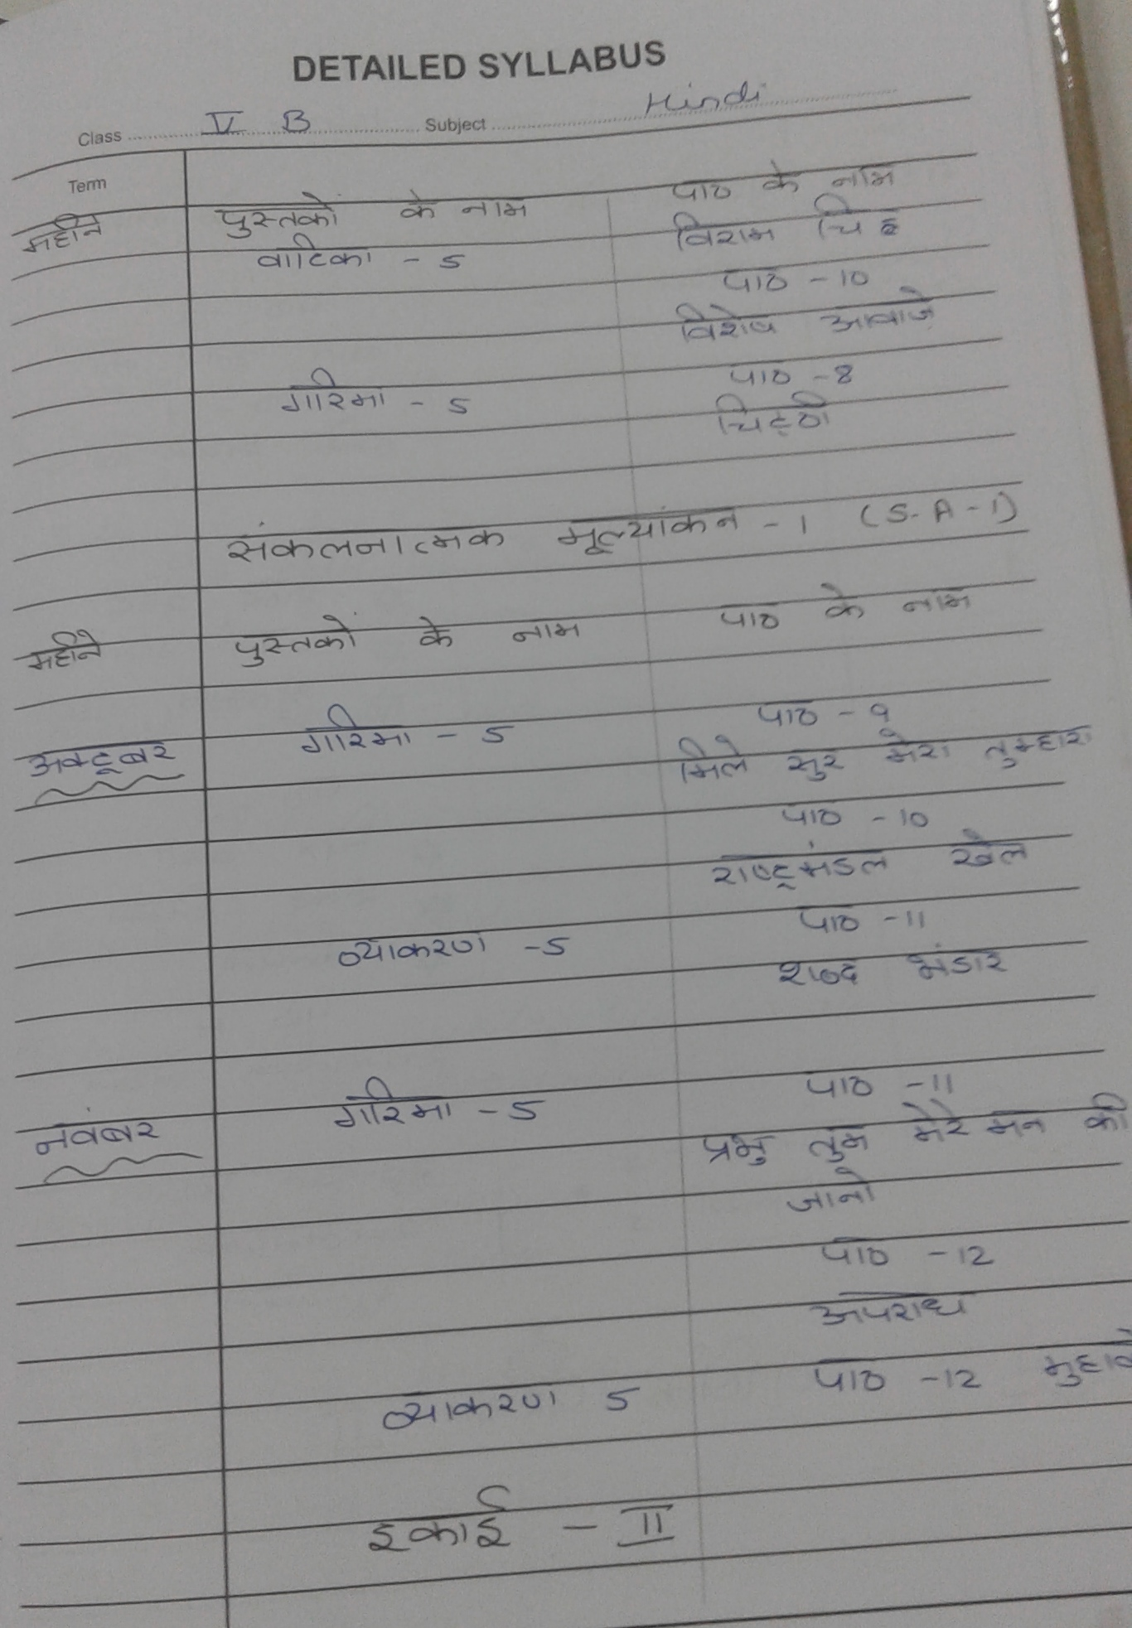
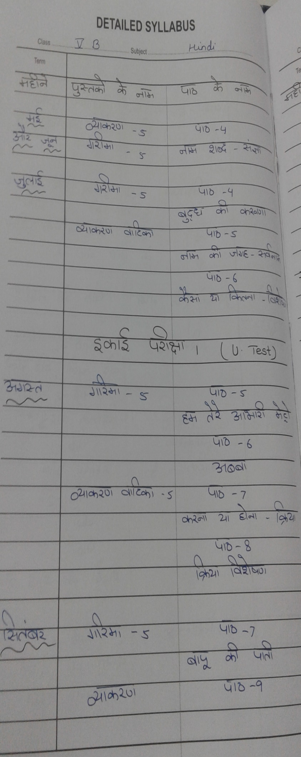

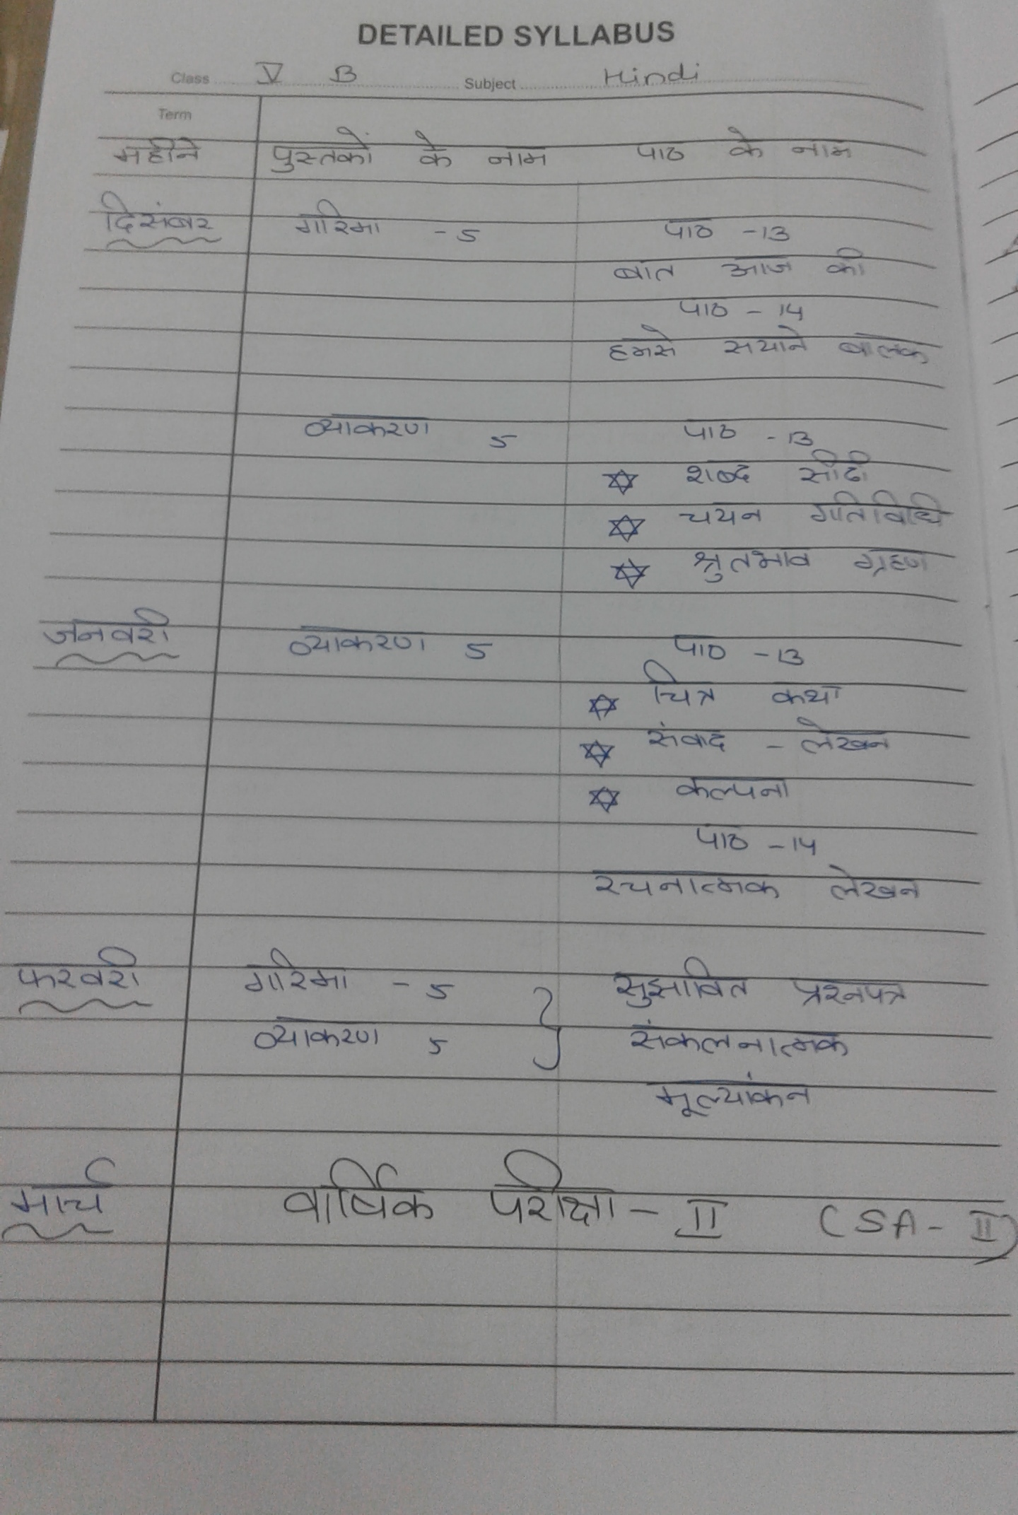
.

AIR FORCE SCHOOL, BAMRAULI
MONTHLY SPLIT-UP OF SYLLABUS
Class: V Subject: Math
Month | Name of the Book | Topic / Sub Topic
April  &  May | Numberline | Unit 1 Place Value  Unit 2 Addition ,Subtraction and their application  Unit 3 Multiplication, Division and their application
June  &  July | Numberline | Unit 3 Multiplication, Division and their application(contd)  Unit 4 Factors  Unit 5 Multiples  Unit 6 Fractions  Revision for PI
Periodic Test :- 01
August | Numberline | Unit 7 Decimals  Unit 8 More About Decimals
September | Numberline | Unit 9 Shapes , Patterns and Nets  Revision for Half Yearly
Half Yearly Exam
October | Numberline | Unit 9 Shapes , Patterns and Nets (Contd)  Unit 10 Geometrical Basics  Unit 11 Measurement
November | Numberline | Unit 12 Perimeter, Area and Volume  Unit 13 Time and Temperature
December | Numberline | Unit 14 Mapping Skills
January | Numberline | Unit 15 Handling Data
Periodic Test :- 02
February | Numberline | Revision for Annual Examination
March | Annual Examination

AIR FORCE SCHOOL, BAMRAULI
MONTHLY SPLIT-UP OF SYLLABUS
Class: V Subject: EVS
Month | Name of the Book | Topic / Sub Topic
April  &  May | Earthworks | Chap 1 Shifting Families  Chap 2 People with special needs  Chap 3 Play Games  Chap 4 Respect all work  Chap 5 The World of Animals
June  &  July | Earthworks | Chap 6 The World of Plants  Chap 7 Our Forest Wealth  Chap 8 The Food we eat
Periodic Test :- 01
August | Earthworks | Chap 9 Food for Health  Chap 10 Plant and Animal Food
September | Earthworks | Chap 11 Shelter For All  Chap 12 Times of Emergencies
Half Yearly Exam
October | Earthworks | Chap 13 Water For life  Chap 14 Aquatic life
November | Earthworks | Chap 15 Fuel for Vehicles
December | Earthworks | Chap 16 The Spirit of Adventure  Chap 17 Our Rich Heritage
January | Earthworks | Chap 18 Machines
Periodic Test :- 02
February | Earthworks | Activities and Revision
March | Annual Examination

AIR FORCE SCHOOL ,BAMRAULI
MONTHLY SPLIT-U OF SYLLABUS
Class: V Subject: Computer

Month | Name of the Book | Topic / Sub Topic
April  &  May | Boot-Click –Enter  Class -V | Le – 1 Topic;- Types of computer
 | Boot-Click –Enter  Class –V | Le- 2 Topic :- Central Processing Unit
June  &  July | Boot-Click –Enter  Class –V | Le -3 Topic :- Data Storage Devices
Periodic Test :- 01
August | Boot-Click –Enter  Class –V | Le – 4 Topic:- Inserting object in MS Word
September | Boot-Click –Enter  Class –V | Le -5 working on Tables in MS word  Revision
Half Yearly Exam
October | Boot-Click –Enter  Class –V | Le – 6 Topic :- Introduction to MS Excel
November | Boot-Click –Enter  Class –V | Le-7 Topic :- More on MS Excel
December | Boot-Click –Enter  Class –V | Le – 8 Topic :- More on MS Power Point
January | Boot-Click –Enter  Class –V | Le – 9 Topic :- Algorithms and Flowcharts
Periodic Test :- 02
February | Boot-Click –Enter  Class –V | Le -10 Topic:- More about the internet
March | Annual Examination

