AIR FORCE SCHOOL, BAMRAULI
MONTHLY SPLIT-UP OF SYLLABUS
Class: II Subject: English
Month | Name of the Book | Topic / Sub Topic
April  &  May |  | Course Book:- L -1 The magician and the Duck  L-2 What are these boys doing  Grammar :- L-1 Remembering What you have learnt  L-2 Naming Words  L-3 Nouns  Work Book:- L-1 and 2
June  &  July |  | Course Book:- L -3 A Freshly baked cake.  L-4 Grace call her friends  Poem:- On the Ning Nang Nong  Grammar :- L-4 Nouns : common and proper nouns  L-5 Nouns : Number  L-24 Prepositions  Workbook:- L-3 and L-4
July | Periodic test -01
August |  | Course Book:- L -5 Where’s Toby?  Poem: The Egg song by tony mitton  Grammar :L- Noun :-Gender  L-7 Who or What an I  L-8 Adjectives  L-9 Verbs  L-10 Verbs present and past Tenses  Workbook:- L-5
September |  | Course Book:- L -6 Can we make friends with a baby robot?  Grammar :L-11 Verbs : Am ,is ,are ,was ,were  L-13 Capital letters and Punctuation  Workbook:- L-6
September | Half Yearly Test
October |  | Course Book:- L -7 Hari and the Fairy  Poem:- Red eyed Rats by Deeksha A Shanker  Grammar :L-14 Months of the year  L-15 Verbs -A Mixed Bag  L-16 Verbs –The ing form  L-21 Opposites  Workbook:- L-7
November |  | Course Book:- L -8 A Good citizen  Poem:- Cat sleep anywhere by Eleanor Farjeon  Grammar :L-17 Helping Verbs : An ,is,Are,was,were  L-18 A, An ,The  L-19 Adverbs  L-20 Jumbled Words
November | Periodic Test -02
December |  | Course Book:- L 9A Brand New Smile  Poem:- The Merry –Go Round by John Mason  Grammar :L-22 Verbs: Some past tense forms  L-23 Pronouns  L-25 Joining word : Conjunctions  Work book :-L-9  Wr18 A, An ,The  L-19 Adverbs  L-20 Jumbled Words
January
February |  | Course Book : Poem I wonder why teannie Kirby  Grammar L-33 Composition  L-27 –L32 –Unseen Passage
March |  | Annual Exam

AIR FORCE SCHOOL, BAMRAULI
MONTHLY SPLIT-UP OF SYLLABUS
Class: II Subject: Hindi
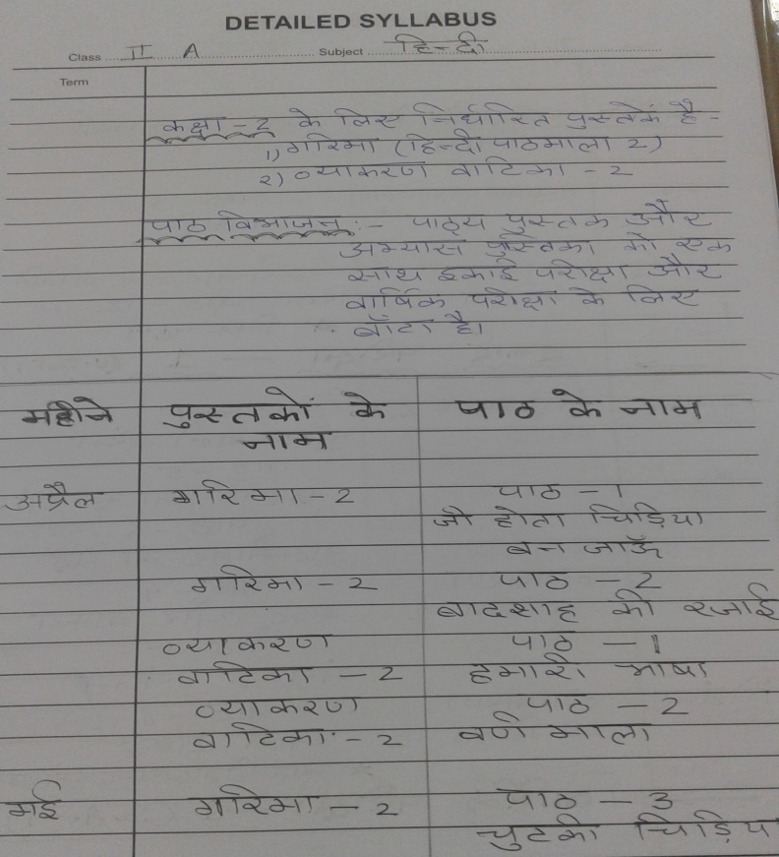
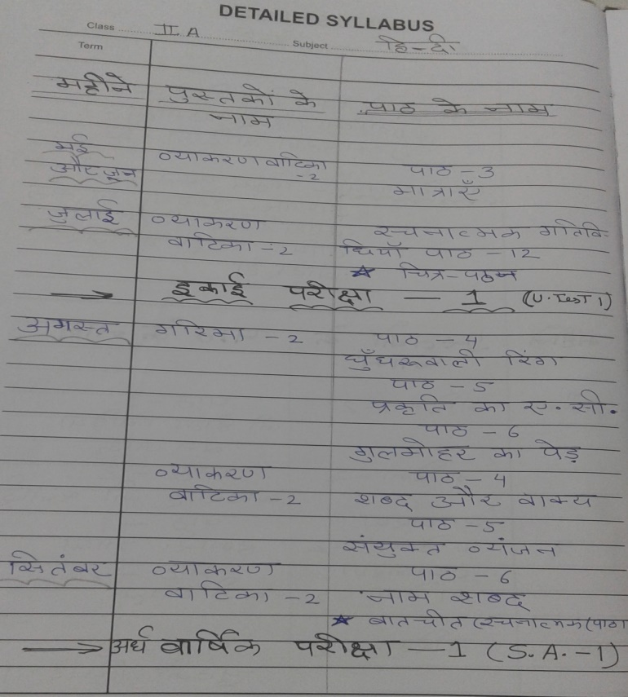

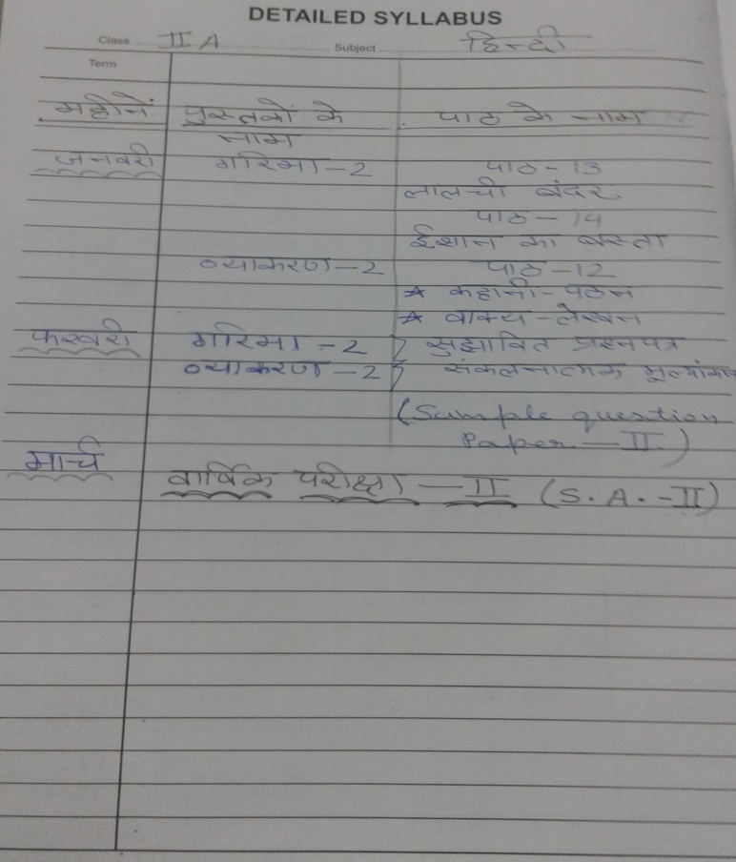
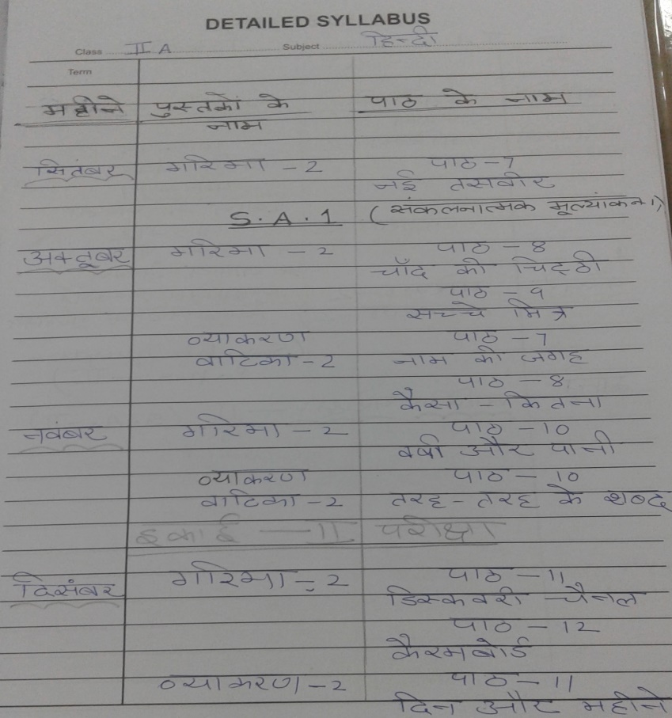

AIR FORCE SCHOOL, BAMRAULI
MONTHLY SPLIT-UP OF SYLLABUS
Class: II Subject: Math
Month | Name of the Book | Topic / Sub Topic
April |  | Chapter :01 Numbers up to 200
May |  | Chapter :02 Addition
June |  | Chapter :3 Subtraction  Chapter :4 Numbers up to 1000
July |  | Periodic Test :-01
August |  | Chapter :05 Addition of Bigger Number  Chapter :06 Subtraction of Bigger Number  Chapter :07 Multiplication
September |  | Revision
October |  | Chapter 8 : Exploring Multiplication Further
November |  | Chapter 9: Shapes and patterns  Chapter 10 Measurement
November |  | Periodic Test 02
December |  | Chapter :11 Time  Chapter :12 Money
January |  | Chapter : 13 Handling Data
February |  | Chapter :14 Division Readiness
March |  | Annual Exam

AIR FORCE SCHOOL, BAMRAULI
MONTHLY SPLIT-UP OF SYLLABUS
Class: II Subject: EVS
Month | Name of the Book | Topic / Sub Topic
April  &  May | Earthworks | Chap 1 My Self  Chap 2 My Body
June  &  July | Earthworks | Chap 3 Growing up  Chap 4 Clothes we wear  Chap 5 Food we eat
July | Earthworks | L-6 Tools we use  L-7 Good Habits  L-8 My Family
August | Earthworks | L-9 House we live in  L-10 Celebrating Festival
September | Earthworks
October | Earthworks | L-11 Having Fun,  L-12 My Neighborhood  L-13 My School
November | Earthworks | L-14 Occupations  L-15 Plant Kingdom  L-16 Animal Kingdom
December | Earthworks | L-17 Means of transport  L-18 Living Safely
January | Earthworks | L-19 The Earth  L-20 Seasons will be started  L-20 Will be continued
February | Earthworks | Revision
March | Earthworks | Annual Exam

AIR FORCE SCHOOL ,BAMRAULI
MONTHLY SPLIT-UP OF SYLLABUS
Class: II Subject: Computer
Month | Name of the Book | Topic / Sub Topic
April | Boot-Click –Enter  Class -II | Le- 01 Topic :- Computer are Amazing
May | Boot-Click –Enter  Class -II | Le-02 Topic :- working of a Computer
June  &  July | Boot-Click –Enter  Class -II | Le-03 Topic :- Input and output Devices
August | Boot-Click –Enter  Class -II | Le -04 Topic:- Switching a computer ON and OFF
September | Boot-Click –Enter  Class -II | Revision for SA I Le- 1,2,3,4
October | Boot-Click –Enter  Class -II | Le-05 Topic ;- More about the keyboard
November | Boot-Click –Enter  Class -II | Le –06 Topic:- More About the Mouse
December | Boot-Click –Enter  Class -II | Le- 07 The computer Memory
January | Boot-Click –Enter  Class -II | Le – 08 Time to Paint Cont…..
February | Boot-Click –Enter  Class -II | Le – 09 Typing with Notepad
March | Boot-Click –Enter  Class -II | Revision
March

