AIR FORCE SCHOOL, BAMRAULI
MONTHLY SPLIT-UP OF SYLLABUS
Class: IV Subject: English
Month | Name of the Book | Topic / Sub Topic
April  &  May | New Learning to Communicate  Workbook  Grammar Tree | MCB :-Le-01 Two Boys in a Jungle and Work Book  Le-02 Humayun was Drawning  Workbook:-Two Boys in a jungle  Humayun was Drawing  Grammar  L1:- Remembering what you have learnt  L2:- Nouns Compound ,Collective ,Concrete ,Abstract  Literary Reader  - The Vet’s greatest Reward
June  &  July | Lit. Reader  Workbook  Grammar Tree  Grammar tree  Lit. Reader | MCB L-3 A Precious gift  L-4 Rikki Tikki Tawi  Workbook L 3, 4  Grammar  Unit 3 Nouns : Number  Unit 4 Verbs : Forms  Unit 5 Verbs : The- ing Forms  Literary Reader  Unit :- Sindbad the sailor  Writing  Letter writing
Periodic Test :- 01
August | New Learning to Communicate  Workbook  Grammar | MCB L 5 And he went to bed  Poem :- the tease  Workbook-And he went to bed  Grammar – verbs ,past participle and perfect tenses  Unit 7: Conjunctions  Literary Reader  The Elephant’s Child -1  Writing  Story Writing
September | New Learning to Communicate  Grammar | Unit 7:- Conjunctions  Unit 10:- pronouns : General  Unit 11:-Personal pronouns  Literary Reader  L-4 The Elephants Child -2
Half Yearly Exam
October | New Learning to Communicate  Workbook  Grammar | MCB  Poem: Every day things  L-6 Kindness of strangers  L-7 Pippi is visited by thieves  Workbook  L- Kindness of Strangers  L-7 Pippi is visited by thieves  Literary Reader  L-5 Hope  L-6 The worth of a candle  Writing  Diary Writing
November | New Learning to Communicate  Workbook  Grammar | MCB L- 8 Animal Communication  L- 9 Puru the brave  Workbook L -8 and 9  Grammar L 12,13  Lit. Reader L 7 How a crow finds Delicious tidbits  L-8 A mad tea party
December | New Learning to Communicate  Workbook  Grammar | MCB Poem: Growing up  Grammar L 21 Agreement of verb with subject  Lit. Reader L 9 We pack
January | New Learning to Communicate  Workbook  Grammar | MCB Poem :- Corvus the intelligent crows  Workbook  L10 Corvus the Intelligent crow  Grammar L -14 Adverbs : Manners ,place and time  Lit. Reader L -10 The Broker promise
Periodic Test :- 02
February | New Learning to Communicate  Workbook  Grammar | MCB L-11 Corvus the intelligent crows  Grammar  L-16 :Interjections  L-17 : Prepositions  L-22 : Kinds of Sentences  L-23 Verbs : Transitive and intransitive  L-24 punctuation  Revision
March | Annual Examination

AIR FORCE SCHOOL, BAMRAULI
MONTHLY SPLIT-UP OF SYLLABUS
Class: IV Subject: Hindi
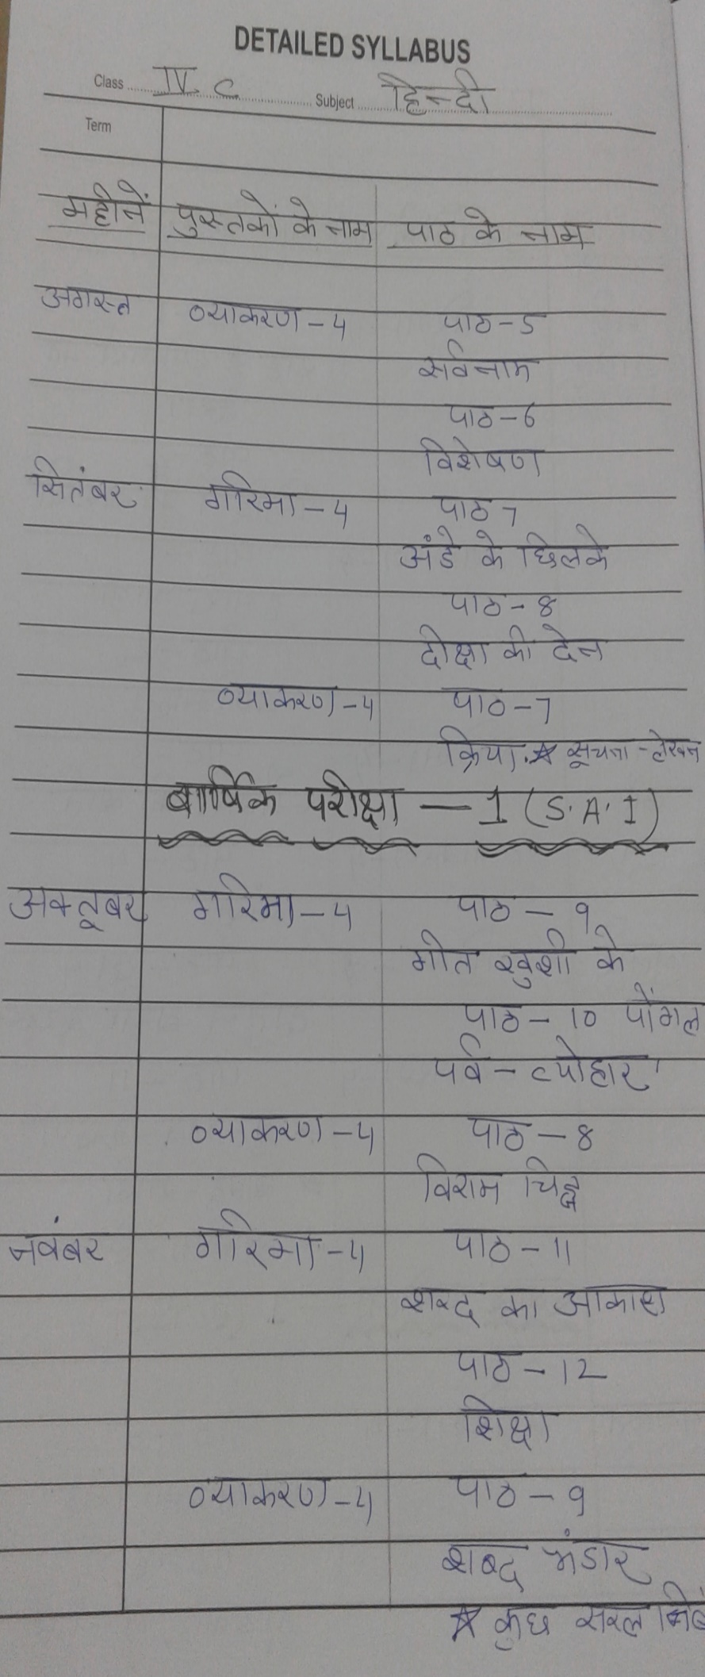
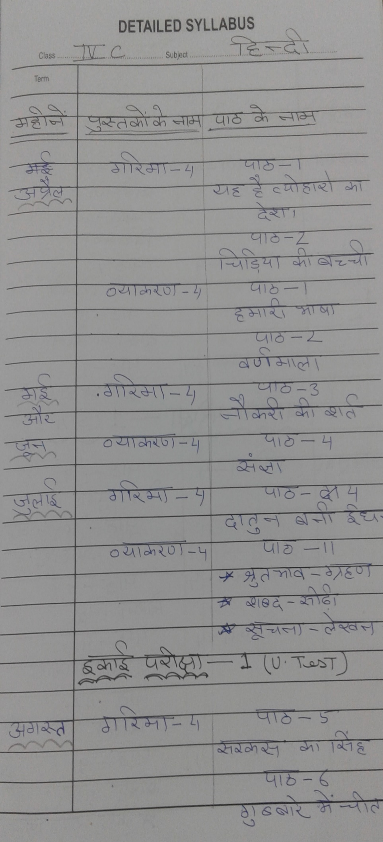

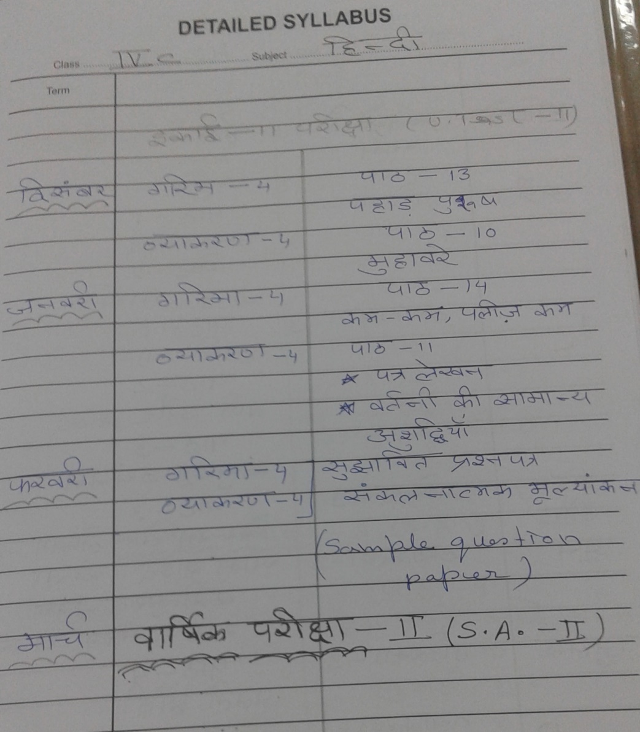

AIR FORCE SCHOOL, BAMRAULI
MONTHLY SPLIT-UP OF SYLLABUS
Class: IV Subject: English
Month | Name of the Book | Topic / Sub Topic
April  &  May | New Learning to Communicate  Workbook  Grammar Tree | MCB :-Le-01 Two Boys in a Jungle and Work Book  Le-02 Humayun was Drawning  Workbook:-Two Boys in a jungle  Humayun was Drawing  Grammar  L1:- Remembering what you have learnt  L2:- Nouns Compound ,Collective ,Concrete ,Abstract  Literary Reader  - The Vet’s greatest Reward
June  &  July | Lit. Reader  Workbook  Grammar Tree  Grammar tree  Lit. Reader | MCB L-3 A Precious gift  L-4 Rikki Tikki Tawi  Workbook L 3, 4  Grammar  Unit 3 Nouns : Number  Unit 4 Verbs : Forms  Unit 5 Verbs : The- ing Forms  Literary Reader  Unit :- Sindbad the sailor  Writing  Letter writing
Periodic Test :- 01
August | New Learning to Communicate  Workbook  Grammar | MCB L 5 And he went to bed  Poem :- the tease  Workbook-And he went to bed  Grammar – verbs ,past participle and perfect tenses  Unit 7: Conjunctions  Literary Reader  The Elephant’s Child -1  Writing  Story Writing
September | New Learning to Communicate  Grammar | Unit 7:- Conjunctions  Unit 10:- pronouns : General  Unit 11:-Personal pronouns  Literary Reader  L-4 The Elephants Child -2
Half Yearly Exam
October | New Learning to Communicate  Workbook  Grammar | MCB  Poem: Every day things  L-6 Kindness of strangers  L-7 Pippi is visited by thieves  Workbook  L- Kindness of Strangers  L-7 Pippi is visited by thieves  Literary Reader  L-5 Hope  L-6 The worth of a candle  Writing  Diary Writing
November | New Learning to Communicate  Workbook  Grammar | MCB L- 8 Animal Communication  L- 9 Puru the brave  Workbook L -8 and 9  Grammar L 12,13  Lit. Reader L 7 How a crow finds Delicious tidbits  L-8 A mad tea party
December | New Learning to Communicate  Workbook  Grammar | MCB Poem: Growing up  Grammar L 21 Agreement of verb with subject  Lit. Reader L 9 We pack
January | New Learning to Communicate  Workbook  Grammar | MCB Poem :- Corvus the intelligent crows  Workbook  L10 Corvus the Intelligent crow  Grammar L -14 Adverbs : Manners ,place and time  Lit. Reader L -10 The Broker promise
Periodic Test :- 02
February | New Learning to Communicate  Workbook  Grammar | MCB L-11 Corvus the intelligent crows  Grammar  L-16 :Interjections  L-17 : Prepositions  L-22 : Kinds of Sentences  L-23 Verbs : Transitive and intransitive  L-24 punctuation  Revision
March | Annual Examination

AIR FORCE SCHOOL ,BAMRAULI
MONTHLY SPLIT-UP OF SYLLABUS
Class: IV Subject: Math

Month | Name of the Book | Topic / Subtopic
April  &  May | Number Line | Le- 01 Place Value  Le- 02 Additions and Subtraction
June  &  July | Number Line | Le -02 Will be completed  Le-03 Multiplications will be started  Le-03 Will be completed  Le-04 Division
 |  | Periodic Test :- 01
August | Number Line | Le-05 Factors  Le-06 Multiples  Le-07 Fraction will be Started
September | Number Line | Le-07 Will be completed  Revision
September | Half Yearly Exam
October | Number Line | Le-8 Decimals
November |  | Le-9 Shapes ,space and patterns  Le-10 Measurement
December | Number Line Number Line | Le – 11 Perimeter & Area  Le-12 Time
January |  | Le -12 will be completed  Le -13 Handling Data will be started
 | Periodic Test :- 02
February | Number Line | Le- 13 will be completed  Revision
March | Annual Examination
AIR FORCE SCHOOL ,BAMRAULI
MONTHLY SPLIT-U OF SYLLABUS
Class: IV Subject: EVS

Month | Name of the Book | Topic / Sub Topic
April  May | Earth Book | Le-01 My Family  Le – 02 The Young ones  Le-03 My extended family  Le-04 Senses of touch and smell  Le-05 Work Around us
June  &  July | Earth Book | Le-06 Games we play  Le-07 Animal Around us  Le-8 Plants around us  Le -9 Flowers
 | Periodic Test :- 01
August | Earth Book | Le -10 The food we eat  Le-11 Eating Together  Le -12 Tongue and teeth
September | Earth Book | Le – 12 Tongue and teeth(continued)  Revision
 | Half Yearly Exam
October | Earth Book | Le – 13 Beak and claws  Le-14 Types of houses
November | Earth Book | Le- 15 Homes of Animals  Le-16 Clean Surroundings  Le-17 Mapping the neighborhood
December | Earth Book | Le- 18 Sources of water  Le-19 Safe water
January | Earth Book | Le- 20 Animals for transport  Le-21 currency and travel
February | Earth Book | Le – 22 Houses and bridges.
March | Earth Book | SA II March

AIR FORCE SCHOOL ,BAMRAULI
MONTHLY SPLIT-UP OF SYLLABUS
Class: IV Subject: Computer
Month | Name of the Book | Topic / Sub Topic
April | Boot-Click –Enter  Class -IV | Le- 01 History of computer
May | Boot-Click –Enter  Class -IV | Le-02 More About MS Word
June  &  July | Boot-Click –Enter  Class -IV | Le-03 Editing in MS word 2010
August | Boot-Click –Enter  Class -IV | Le -04 Formatting in MS Word 2010
September | Boot-Click –Enter  Class -IV | Revision for SA I Le- 1,2,3,4
October | Boot-Click –Enter  Class -IV | Le-05 Introduction to MS Power Point 2010
November | Boot-Click –Enter  Class -IV | Le – 06 More about Logo
December | Boot-Click –Enter  Class -IV | Le- 07 Procedure in LOGO
January | Boot-Click –Enter  Class -IV | Le – 08 Internet and its Use
February | Boot-Click –Enter  Class -IV | Le – 09 Introduction to open office.org
March | Boot-Click –Enter  Class -IV | Revision for
March |  | SA II

