AIR FORCE SCHOOL BAMRAULI
ANNUAL SPLIT-UP OF SYLLABUS
ACADEMIC SESSION -2026-27

CLASS :- 2SUBJECT : ENGLISH

BOOK NAME:LITRATURE - MRIDANG, GRAMMAR- EVERYDAY GRAMMAR, WORKBOOK-UDAAN

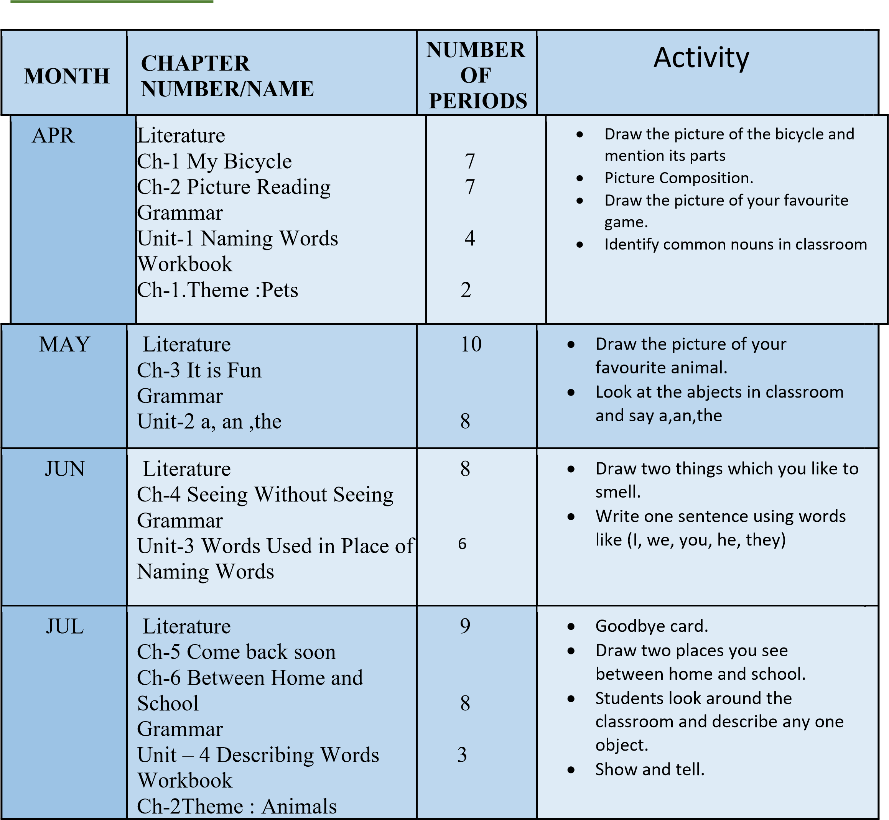

AUG | Literature  Ch-7This is my town  Grammar  Unit:-5 this/that/these/those Unit:-6 Doing and Helping Words.  Workbook  Ch-3Theme:Season | 6  5  2 | • • •  • | Town Map Poster.  Classroom point game.  Name the doing words in the chapter or write one sentence My Favourite season.
SEP | Literature  Ch-8 A Show of Clouds  Grammar  Unit:-7Words That Show Time of an action.  Workbook  Ch-4 Theme-Problem Solving | 5  3  2 | •  •  • | Make two-three cloud using stick and cotton.  Time words activity.  Write 3 lines: 1. Yesterday I *_. 2.  Today I *_. 3. Tomorrow I will ___.”
OCT | Literature  Ch-9 My Name  Grammar  Unit-8 Position Words. | 4  4 | •  • | Name Badge + Introduce Simon Says Positions
NOV | Literature  Ch-10 The Crow  Grammar  Unit-9 Joining Words  Unit-10 The Sentence  Workbook  Ch-5 | 5  4  4  3 | • • •  • | Meet the Crow.  Draw crow and pot.  Human Sentence Train. Flash card Match-Make one sentence.
DEC | Literature  Ch-11 The Smart Monkey  Grammar  Unit-11 Special Marks  Workbook  Ch-6 Dreams and Fantasy | 5  3  2 | • • •  • | Meet the Monkey.  What Mark Am I ?  Vocabulary and Meaning.  Sentence Frame – "If I Were..."
JAN | Literature  Ch-12 Little Drop of Water  Grammar  Unit-12 Understanding words  Unit -13 Reading | 5  3  2 | • •  • | Value Talk – "Save Water" Poster on “save water” Echo-Reading.
FEB | Literature  Ch-13We are all Indians  Grammar  Unit-14 Writing  Workbook  The Rainbow ( Reading) | 5  5  2 | • • •  • |  | Chant+Action--We are one Flag Talk-Our Tricolour Draw+label -My India.  Colour Chant-VIBGYOR

S.NO | EXAM | TENTATIVE  DATE | SYLLABUS
1 | PERIODIC TEST - 1 | 6-13July | Literature  Ch-1,2,  Grammar  Unit-1,2,3
2 | HALF YEARLY EXAMINATION | 17-30September | Literature  Ch-1,2,3,4,5,6  Grammar  Unit-1,2,3,4,5,6,7
3 | PERIODIC TEST - 2 | 23Nov -1 Dec | Literature  Ch-7 8,9,  Grammar  Unit-8,9,10
4 | ANNUAL  EXAMINATION | 1-11March | Literature  Ch-7,8,9,10,11,12,13  Grammar  Unit-8,9,10,11,12,13,14

